INTRODUCTION TO ELECTRICAL ENGINEERING [19AIE104]

S1 B.TECH CSE (AIE)

**AUTOMATIC PUMP AND WATER LEVEL CONTROL**

A Project Report

*Submitted b*y

ROLL NUMBER NAME

AM.EN.U4AIE21117 ARJUN U

AM.EN.U4AIE21120 AVADHUTA SAI VARUN

AM.EN.U4AIE21137 KARAN RAJESH NAIR

AM.EN.U4AIE21160 SIDHARTH S KUMAR

**

AMRITA SCHOOL OF ENGINEERING

AMRITA VISHWA VIDYAPEETHAM

AMRITAPURI 690 525

January 2022

**ABSTRACT**

In countries including India, Indonesia, Mexico, Guatemala, and El Salvador, a city water authority supplies the clean water and pumps it into large ground-level storage tanks. But in many areas, it is observed that water tanks are overflowing because there was no proper checking to ensure whether the tank was filled or not. Even in households having a well and independent water pump system, many litres of water are being wated daily. This causes a wastage of both water and energy. As we all know water is one of the most important resources needed for survival of humans. So, it is necessary to use it wisely and reduce wastage.

Our project Automatic Pump and Water Level Controller makes use of Arduino and Ultrasonic sensor to monitor and control the water level in tanks. It can also automatically fill up the tank when the water level is too low and makes sure that there is no wastage of water due to overflowing. When the system is switched on, the ultrasonic sensor takes up continuous reading of water level in the tank through which the percentage of water level is calculated which is visible to the user on the lcd screen. When the water level becomes too low with the help of Arduino the water pump automatically switches on and starts to fill up the tank. User can also know whether the pump is on or not with the help of the led bulb and servo motor. When the water tank is filled and water level is sufficient, the pump is automatically switched off.

Using this system, the user can continuously monitor the water level and also doesn’t have to worry about switching on the water pump manually thus reducing the manual labour required. This helps many people such as the elderly who might struggle to switch off the pump on their own. Once the system is switched on the user doesn’t have to check on it again as all the functionalities are being carried out automatically by the system. This also makes sure that the wastage of water by overflowing can be reduced significantly thus helping is saving litres of water which otherwise would have been wasted. The system is relatively simple and is also easy to install with minimum maintenance required.

**TABLE OF CONTENTS**

|  |  |  |
| --- | --- | --- |
|  | |  |
| 1 | INTRODUCTION | 4 |
| 2 | COMPONENTS REQUIRED | 5 |
| 3 | CIRCUIT DIAGRAM | 6 |
| 4 | WORKING OF SYSTEM | 7 |
| 5 | RESULTS AND ANALYSIS | 7 |
| 6 | CONCLUSION | 7 |
| 7 | APPENDIX | 8 |
| 8 | REFERENCE | 18 |

**INTRODUCTION**

Water is an essential element to a person’s life. The human body is composed of 75% water in infants and 55% water in the elderly. Not drinking enough water leads to dehydration which can many detrimental effects on the body, both and physical and mental. Studies show dehydration decreases cognitive function in children and increases the risk for delirium in the elderly. Water is also important in maintaining healthy functioning kidneys, gastrointestinal function, and heart function.

Although many countries around the world are having adequate supply of water, this is not the case in many other countries. An estimated 884 million people in the world do not have access to safe water supplies. In many developing countries like India, people must spend hours every day collecting water from distant places because they do not have a nearby water source. It is estimated that by 2025, “1.8 billion people will be living in countries or regions with absolute water scarcity, and two-thirds of the world's population could be living under water stressed conditions.” So, it is necessary to use water wisely and reduce wastage of one of the most vital resources on Earth.

One way by which there is a lot of wastage of water in countries like India are overflowing water tanks. While most people can manually check their water system effectively and switch off the pump after its use, they usually switch it off after the tank gets filled and overflow happens. This also happens in city and municipality water tanks due to the lack of proper checking. This can waste litres of water per day. The solution to this problem is an Automatic Pump and Water Level Controller. This device monitors the water levels tank and switches the water pump on when the water level is too low. It needs to be completely autonomous requiring no user input beyond the initial installation. Users need an affordable system that draws little power to ensure low running costs. The system must function accurately so that residents’ water tanks can fill as much as possible without wasting water and energy. Not every pump system requires the same power source, so the control system must support various pumps as well as common voltage sources. Additionally, the Automatic Pump and Water Level Controller system likely resides in an outdoor setting near water necessitating a high level of weather resistance. Lastly, customers need the device small and light for ease of transportation.

**COMPONENTS REQUIRED**

The components used for the project

1. Arduino Uno R3
2. Ultrasonic Distance Sensor
3. Liquid Crystal Display (16x2)
4. DC Motor
5. NPN Transistor (BJT)
6. 220 Ω Resistor
7. 100 Ω Resistor
8. Positional Micro Servo
9. Slide Switch
10. LED
11. Wires

**CIRCUIT DIAGRAM**

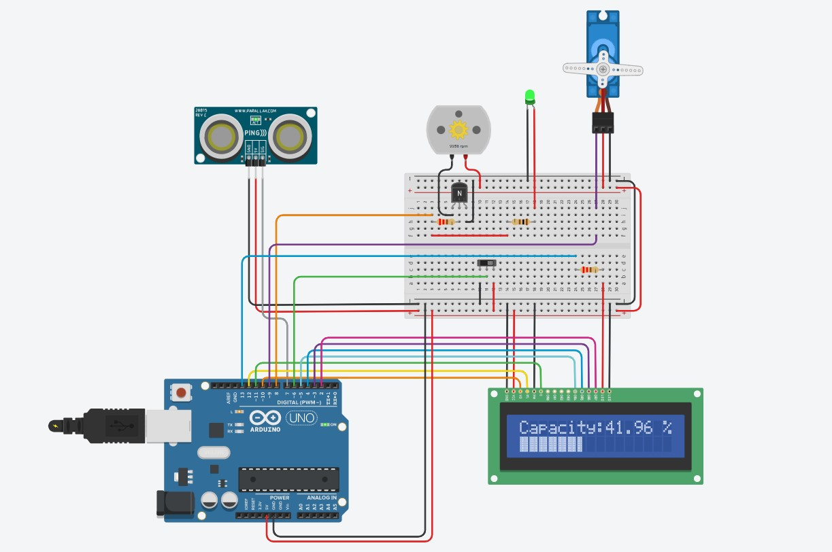

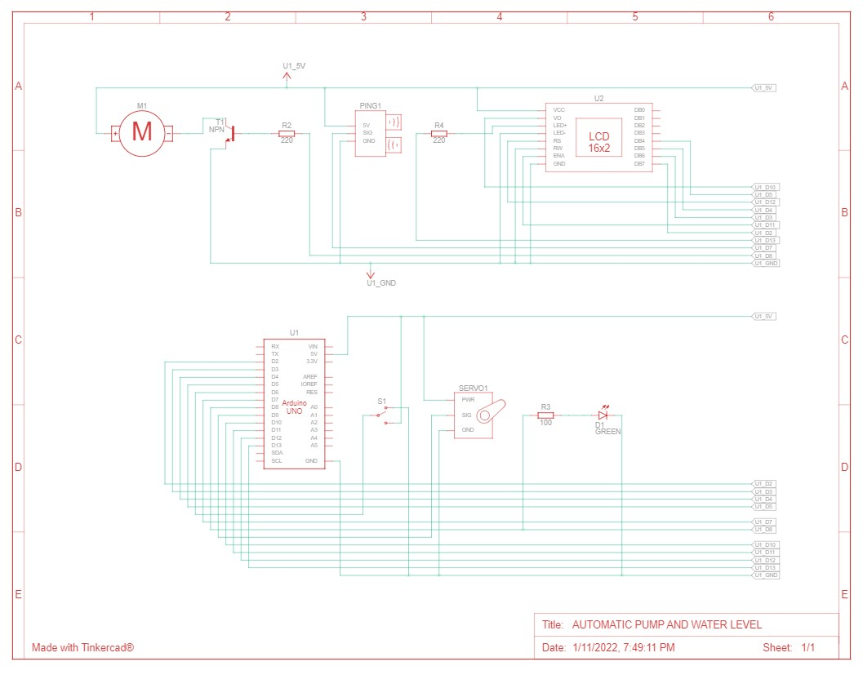

**WORKING OF THE SYSTEM**

All the components in the project is controlled by Arduino which is micro controller. The ultrasonic sensor finds the level of the water by finding the time for the wave emitted by the emitter which bounces from the surface of the water and is received in the reviver. It is then multiplied with the speed of the sound to find the level of the water. This distance is used to switch on and off the DC motor. When the water level is less than the reference the DC motor is switched on and pumps water, else if the water level is at the required level the DC motor is switched off. To indicate the working of the DC motor we use an LED. An NPN transistor is used to amplify the signal to the DC motor. An LCD screen is used to show the water level in percentage. The LCD also has a progress bar which increases and decreases as per the water level. A servo motor is used here to represent if the system is on or off by changing its hands position. A slide switch is used to switch off and switch on the system.

**RESULT**

When the system is activated, the water pump is automatically switched on when the water level is too low. After the water level reaches the maximum level the water pump is switched off automatically. Real time readings of the water level are also displayed in the lcd screen.

**CONCLUSION**

Water is the important natural resource that should be used more efficiently. In earlier days users had to manually go check the water level of the water tank, this caused the uncontrolled use of water leading to wastage of water and ultimately causing water scarcity. To avoid more human effort and errors water automation system can be used. This is an efficient and economical wat to reduce water wastage and human efforts.

Automatic Pump and Water Control System -

<https://www.tinkercad.com/embed/bayLkrNtSws>

**APPENDIX**

*#include* <LiquidCrystal.h>

*#define* length 16.0

*#include* <Servo.h>

*// Declaring the variables that we are going to use*

double percent=100.0;

unsigned char b;

unsigned int peace;

int max_distance = 0;

int calc_distance = 0;

int Button_state = 0;

int count = 0;

Servo servo_9; *// setting up the servo*

LiquidCrystal LCD(12, 11, 5, 4, 3, 2); *// setting pins for LCD screen*

*// Setting up the screen*

byte p1[8] = {

  0x10,

  0x10,

  0x10,

  0x10,

  0x10,

  0x10,

  0x10,

  0x10};

byte p2[8] = {

  0x18,

  0x18,

  0x18,

  0x18,

  0x18,

  0x18,

  0x18,

  0x18};

byte p3[8] = {

  0x1C,

  0x1C,

  0x1C,

  0x1C,

  0x1C,

  0x1C,

  0x1C,

  0x1C};

byte p4[8] = {

  0x1E,

  0x1E,

  0x1E,

  0x1E,

  0x1E,

  0x1E,

  0x1E,

  0x1E};

byte p5[8] = {

  0x1F,

  0x1F,

  0x1F,

  0x1F,

  0x1F,

  0x1F,

  0x1F,

  0x1F};

*// ultrasonic sensor (trigger = emitting , echopin = recieve)*

long readUltrasonicDistance(int triggerPin, int echoPin)

{

  pinMode(triggerPin, OUTPUT); *// Setting up the triggerpin to give output*

*// Sets the trigger pin to LOW state for 2 microseconds*

  digitalWrite(triggerPin, LOW);

  delayMicroseconds(2);

*// Sets the trigger pin to HIGH state for 10 microseconds*

  digitalWrite(triggerPin, HIGH);

  delayMicroseconds(10);

*// Sets the trigger pin back to LOW state*

  digitalWrite(triggerPin, LOW);

  pinMode(echoPin, INPUT); *// Setting up the echopin to give input*

*// Reads the echo pin, and returns the sound wave travel time in microseconds*

*return* pulseIn(echoPin, HIGH);

}

*//setting up the pins*

void setup()

{

  pinMode(6, INPUT);

  pinMode(8, OUTPUT);

  pinMode(10, OUTPUT);

  pinMode(13, OUTPUT);

  LCD.createChar(0, p1);

  LCD.createChar(1, p2);

  LCD.createChar(2, p3);

  LCD.createChar(3, p4);

  LCD.createChar(4, p5);

  LCD.begin(16, 2);

  digitalWrite(10, HIGH);

  digitalWrite(13, LOW);

}

*// Loop so that we can take real time values*

void loop()

{

*// v = d/t*

  calc_distance = 0.01723 * readUltrasonicDistance(7, 7); *// d = v*t*

  Button_state = digitalRead(6); *// To check if the switch is on or not*

  max_distance = 336; *// Max range of the sensor*

  percent = (calc_distance/336.0)*100.0;

*if* (Button_state == HIGH){

    digitalWrite(10, LOW);

    digitalWrite(13, HIGH);

    servo_9.attach(9);

    count++;

*// Initial message on screen*

*if* (count == 1){

      delay(100);

      LCD.setCursor(0,0);

      LCD.print("                ");

      LCD.setCursor(0,1);

      LCD.print("                ");

      delay(100);

      LCD.setCursor(0, 0);

      LCD.print("POWER ON");

      LCD.setCursor(0, 1);

      LCD.print("VALVE & PUMP");

      delay(100);

    }

*// when capacity is low the pump is turned on*

*if* (calc_distance > max_distance-100) {

*if* (count ==1){

        delay(1000);

      }

      servo_9.write(90); *// Rotates the servo in 90 degree*

*if* (count ==1){

        delay(1000);

      }

      digitalWrite(8, HIGH); *//powers the dc motor and led*

      digitalWrite(9, HIGH); *//powers the servo*

    }

*// when capacity is full the water pump stops*

*if* (calc_distance < max_distance-319) {

*if* (count ==1){

        delay(1000);

      }

      digitalWrite(8, LOW); *// dc motor turned off*

*if* (count ==1){

        delay(1000);

      }

      servo_9.write(0); *// servo is moved back to initial position*

    }

*// Capacity displayed in screen*

*if* (count ==1){

      delay(1000);

    }

    LCD.setCursor(0,0);

    LCD.print("Capacity : ");

    LCD.print(100 - percent);

    LCD.print(" %   ");

    LCD.setCursor(0,1);

    double a=length/100*(100-percent);

*// drawing black rectangles on LCD*

*if* (a>=1) {

*for* (int i=1;i<a;i++) {

        LCD.write(4);

        b=i;

      }

      a=a-b;

    }

    peace=a*5;

*// drawing charater's column*

*switch* (peace) {

*case* 0:

*break*;

*case* 1:

      LCD.print(char(0));

*break*;

*case* 2:

      LCD.write(1);

*break*;

*case* 3:

      LCD.write(2);

*break*;

*case* 4:

      LCD.write(3);

*break*;

    }

*//clearing line*

*for* (int i =0;i<(length-b);i++) {

      LCD.print(" ");

    }

    ;

  }

*// Switches off everything when switch is off*

*if* (Button_state == LOW){

    LCD.setCursor(0, 0);

    LCD.print("                ");

    LCD.setCursor(0, 1);

    LCD.print("                ");

    delay(100);

    LCD.setCursor(0, 0);

    LCD.print("POWER OFF");

    LCD.setCursor(0, 1);

    LCD.print("VALVE & PUMP");

    delay(1000);

    digitalWrite(8, LOW);

    delay(1000);

    servo_9.write(0);

    delay(1500);

    LCD.setCursor(0,0);

    LCD.print("                ");

    LCD.setCursor(0,1);

    LCD.print("                ");

    delay(100);

    digitalWrite(10, HIGH);

    digitalWrite(13, LOW);

    count = 0;

  }}

**REFERENCE**

1. Arduino Lessons by Paul McWhorter –

<https://www.youtube.com/watch?v=d8_xXNcGYgo&list=PLGs0VKk2DiYx6CMdOQR_hmJ2NbB4mZQn->

1. Arduino-based automatic water level indicator and controller project we are going to estimate the water level using ultrasonic sensors <https://maker.pro/arduino/projects/automatic-water-level-indicator-and-controller-using-arduino-1>
2. Water Level Monitoring

<https://create.arduino.cc/projecthub/Ramesh_Dofbot/water-level-monitoring-33aa4c>

1. News on wastage of water

<https://www.thehindu.com/news/cities/Madurai/overhead-tank-overflows-at-a-time-of-water-crisis/article28190100.ece>

<https://www.newindianexpress.com/cities/chennai/2019/jun/29/tamil-nadu-water-crisis-overflowing-tanks-for-some-pipe-dreams-for-others-1996912.html>

<https://www.deccanherald.com/city/bwssb-targets-overhead-tank-water-wastage-in-new-move-773145.html>

1. Studies

<https://www.thehindu.com/news/cities/Delhi/40-per-cent-of-water-supply-gets-wasted-Study/article16836247.ece>

<https://www.ijraset.com/fileserve.php?FID=14330>